Verification of Xpp period tracing using different methods.

PNF 1M8 FCATR =10

1. 1-par bifurcation

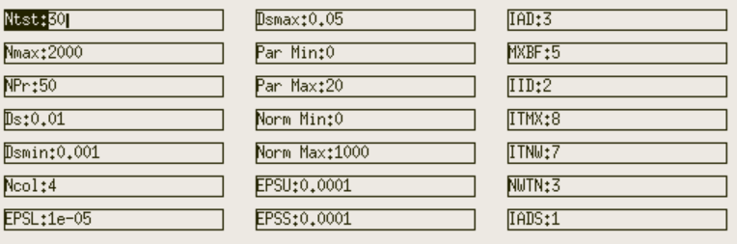

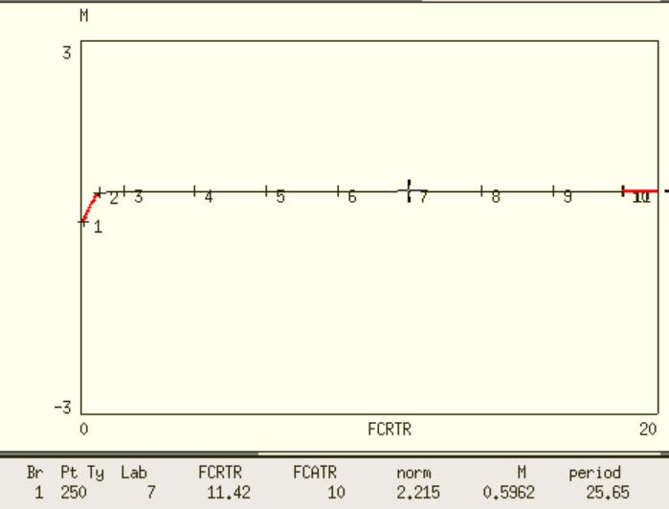

As lab 7 point suggests, FCRTR=11.42 and FCATR=10 corresponds to period value T=25.65

1. The figure below is plotted by “Usr period” -> “Fixed Period”.

By eyeballing it, FCRTR=11.42 and FCATR=10 corresponds to period value T is 60~65

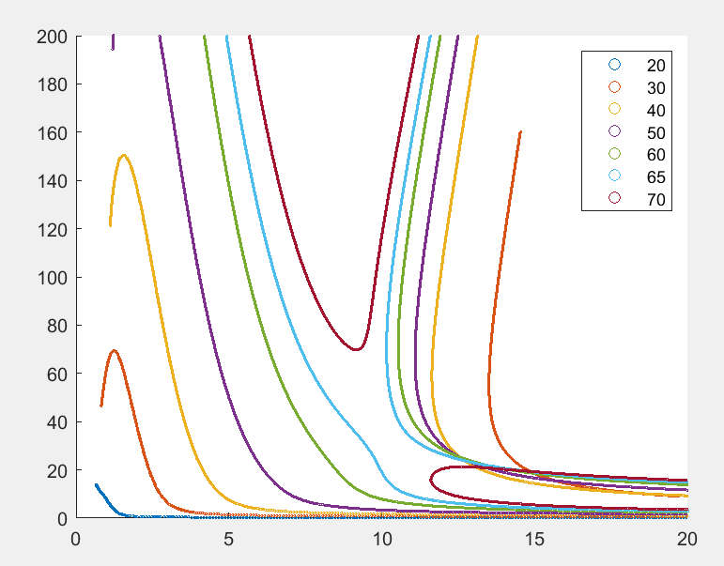

Check “Usr period” (T=20,30…100) points, and FCRTR=10.44 corresponds to T=63.66 (though no information about FCATR). But at least these two methods result are not consistent.

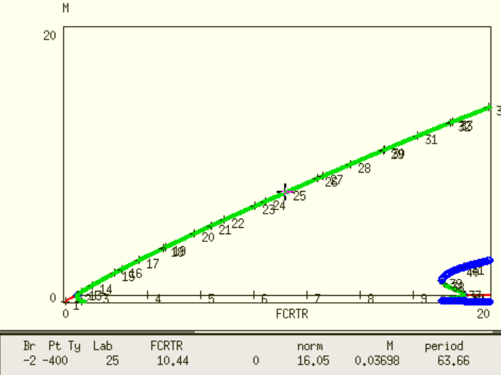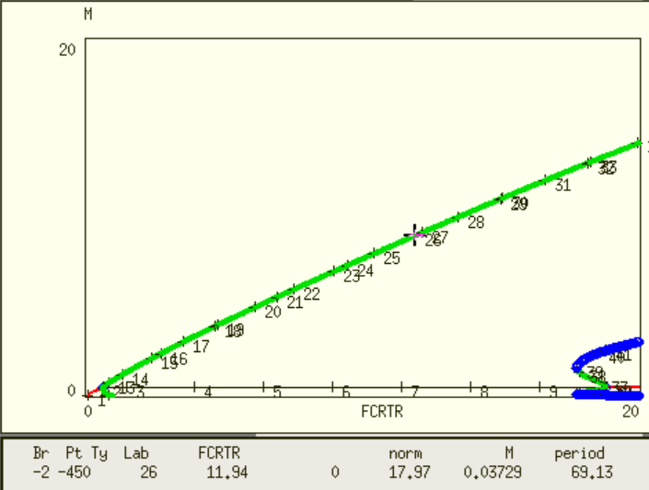

# The oscillation does not go below 0.

1. Manually calculate the period for FCRTR=11.42 and FCATR=10

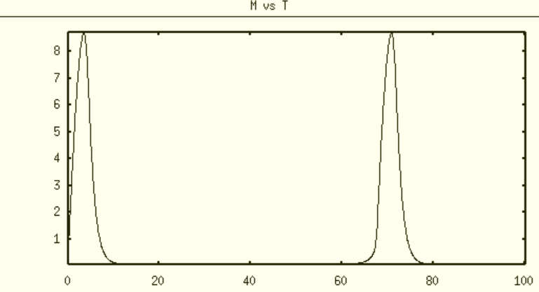

as the figure above shows the period T~65

Conclusion, the period calculate from 1-par bifurcation is not correct. Period tracing using “Usr period” -> “Fixed Period” seems more reliable.

1. 2-par bifurcation curve comes with period value, previously we tested that period tracing using method 2 is consistent with this method 4 for the points located in the boundary.

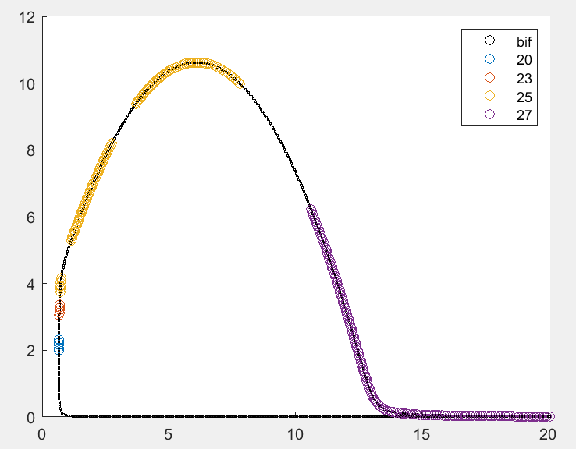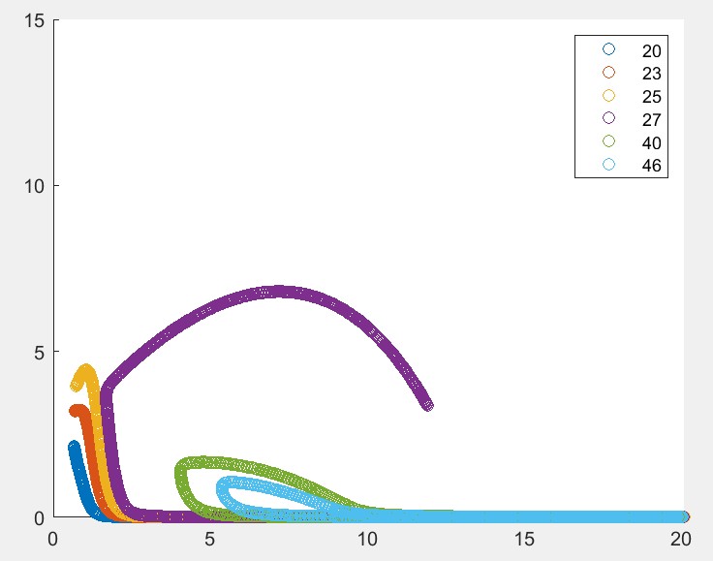

1. (2)

Fig4C NNF 1M8 model period tracing. (1) 2-par bifurcation with user specified period (2) Period tracing using method 2. Though not superimposed here, the left part of two figures where T=20,23,25 match with each other.

In conclusion, method 1 does not work. Method 2-4 seem to give consistent and reliable result for period tracing.